 COSC 1320
Thanh Vo
B12
Name: _________________ Seat # __

Estimated Hours 1
1
Actual Hours

TA (Textual Analysis) for UML USE CASE Diagram MODEL
Programming Assignment 2:
(10 points)
(Due date found in the COSC 1320 BB Calendar!)
You must use Microsoft WORD program. Insert the TEMPLATEs for Actors and Use Cases in this Requirements Document.

Please have Step 1, 2, 3, and 4 in this order.

PLEASE use the “TA for UML USE CASE Diagram MODEL Movie Company System.doc” AS TEMPLATE.
(Do not Show STEP 1,…; do not change Line Numbers; do not change Number of Pages)

Any DIAGRAM that is NOT the result of CUT and PASTE
WILL BE IGNORED. (YOU WILL GET ZERO POINTS)

Requirements Analysis: Construct the UML USE CASE Diagram MODEL

ProgrammingAssignment2 APPLICATION for ANIMATING an electrical CIRCUIT using SWING.

Write an application that controls an electrical circuit that has a power source, a switch, and a light bulb. The user wants to control the names of the Labels, thus they must be read from a data file named “Programming Assignment 2 Data.txt”.

A sample input file “Programming Assignment 2 Data.txt” follows:
A1: User
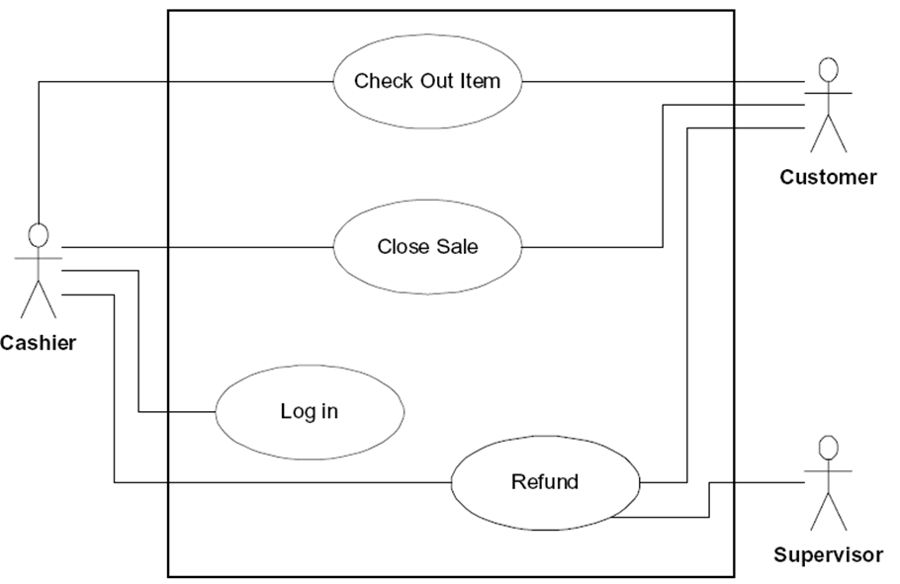
Animation of an Electrical Circuit
Power Supply
Switch
Light bulb

You will have two buttons, labeled Open and Close. When you click on Close (see that the switch shows that it is closed - redraw) the light bulb should turn on. When you click on Open (see that the switch shows that it is open - redraw) the light bulb should turn off.
UC2: UCClose1
UC1: UCOpen1
UC4: UCClose2
UC3: UCOpen2

The title of your window must be “Programming Assignment 2”.

Create a ProgrammingAssignment2.java that contains the main method.
JAVA Exception Handling is also required.

You cannot use a GUI Designer!
One Class per .java file!
Look up Chapter 18 for drawing JAVA Classes).

Each .java file must have these 4 lines of comments (you will lose 5 points if not):
// COSC 1320 Summer 2015
// Name:
// Programming Assignment 2
// This is my own work; I will not post

A1: User
Controller
UCOpen1
UCClose1
UCOpen2
UCClose2

UC 1

UC2

UC3

UC4

UC1 UCOpen1 Description
Name: | UC1: UCOpen1
Actor: | User
Description: | This use case interprets a process which the program will set the circuit on the top to open which means there is no electric on top
Successful Completion: | User hit the button OpenSwitch 1. The top light bulb and left switch will have black color which means there is no light. The left switch will be shown as being opened (one end disconnected to the circuit)
Alternative | none
Pre-condition: | All switches are opened (one end disconnected to the circuit) or closed (continuous circuit). In another case, one of the switches is opened and the other one is closed. All lights and switches are red or black. In another case, one light and one switch are black and the other ones are red.
Post-condition: | The left switch is set to open, hence, the top light bulb and the left switch are set color to black
Assumptions: | None

UC2 UCClose1 Description
Name: | UC2: UCClose1
Actor: | User
Description: | This use case interprets a process which the program will set the circuit on the top to close which means there is electric on top
Successful Completion: | User hit the button CloseSwitch 1. The top light bulb and left switch will have red color which means there is light. The left switch will be shown as being closed (continuous line on top left side)
Alternative | none
Pre-condition: | All switches are opened (one end disconnected to the circuit) or closed (continuous circuit). In another case, one of the switches is opened and the other one is closed. All lights and switches are red or black. In another case, one light and one switch are black and the other ones are red.
Post-condition: | The left switch is set to close, hence, the top light bulb and the left switch are set color to red
Assumptions: | None

UC3 UCOpen2 Description
Name: | UC3: UCOpen2
Actor: | User
Description: | This use case interprets a process which the program will set the circuit at the bottom to open which means there is no electric at bottom
Successful Completion: | User hit the button OpenSwitch 2. The bottom light bulb and the right switch will have black color which means there is no light. The right switch will be shown as being opened (one end disconnected to the circuit)
Alternative | none
Pre-condition: | All switches are opened (one end disconnected to the circuit) or closed (continuous circuit). In another case, one of the switches is opened and the other one is closed. All lights and switches are red or black. In another case, one light and one switch are black and the other ones are red.
Post-condition: | The right switch is set to open, hence, the bottom light bulb and the right switch are set color to black
Assumptions: | None

UC4 UCClose2 Description
Name: | UC4: UCClose2
Actor: | User
Description: | This use case interprets a process which the program will set the circuit at the bottom to close which means there is electric at bottom
Successful Completion: | User hit the button CloseSwitch 2. The bottom light bulb and right switch will have red color which means there is light. The right switch will be shown as being closed (continuous line on bottom right side)
Alternative | none
Pre-condition: | All switches are opened (one end disconnected to the circuit) or closed (continuous circuit). In another case, one of the switches is opened and the other one is closed. All lights and switches are red or black. In another case, one light and one switch are black and the other ones are red.
Post-condition: | The right switch is set to close, hence, the bottom light bulb and the right switch are set color to red
Assumptions: | None

